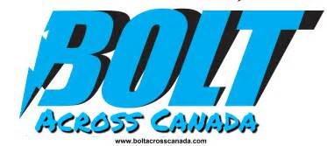
Contact Barbara Hetherington  Telephone 1-604-741-7089 or  Cell 1-740-1425 (Buddy Boyd)  Email boltacrosscanada@gmail.com  Website www.boltacrosscanada.com | FOR IMMEDIATE RELEASE  June 26, 2017

Driving coast to coast in an all-electric chevy bolt

Zero Waste Canada promotes Zero Waste and Zero emissions lifestyles from coast to coast
Victoria, , June 26, 2017– On July 1, Barbara Hetherington and Buddy Boyd will be launching a cross country road trip to promote Zero Waste and zero emissions lifestyles. The couple will be beginning their road trip by dipping the wheels of the Chevy Bolt at 9am on July 1 at Anglers Boat Launch at 75 Dallas Road.
Buddy Boyd, one of the directors of the non-profit Zero Waste Canada, says “There have been other electric vehicles that have crossed Canada; most of these have been Tesla electric vehicles. We believe this will be the first Chevy Bolt to make the trip from coast to coast. This is also the first time that Zero Waste Canada has taken toured Canada to promote Zero Waste.”
The couple will be blogging about their experiences on the road. They will also be meeting with environmental groups, community groups and businesses to share the message that it is possible to create positive change by making more sustainable lifestyle choices.
“This is a road trip with a purpose. We want to talk to people in their own communities and share their stories about their successes and challenges living more sustainable lives,” adds Barbara Hetherington.
The pair will be travelling to Newfoundland where they will also dip their wheels in the east coast waters.
Zero Waste Canada is a grassroots non-profit organization dedicated to creating world without waste.
Bolt Across Canada is a Canada150 project promoting lifestyle changes that reduce waste including tailpipe waste.
# # #
If you would like more information about this topic, please contact Barbara Hetherington at 1-604-741-7089 or email at boltacrosscanada@gmail.com.

